NOTES for Day 3: Getting Repeat Business

The THANK YOU Strategy

Today’s challenge is very, very simple…Reaching out to previous customers to say thanks and NOT to pitch them…

Here’s what I mean…

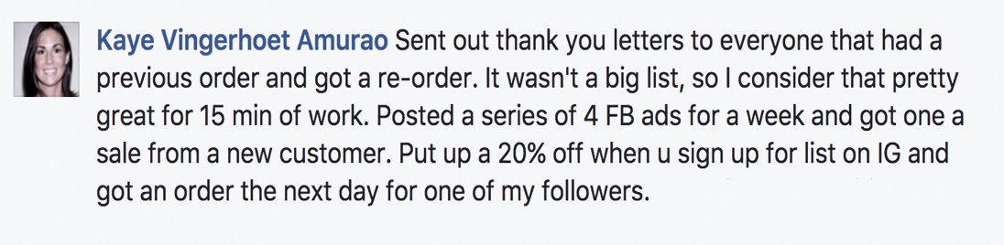

Info from Jane’s student, Joanne…

NOTE: We’re doing this strategy manually for this challenge – one by on email from your personal business email account – do not use NOT Mailchimp or Constant Contact as it will not have the same effect.

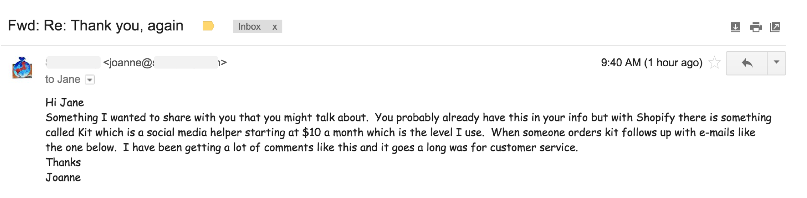

You can also set up an automatic email like this, depending on what system you use, the Kit app from Shopify is now free.

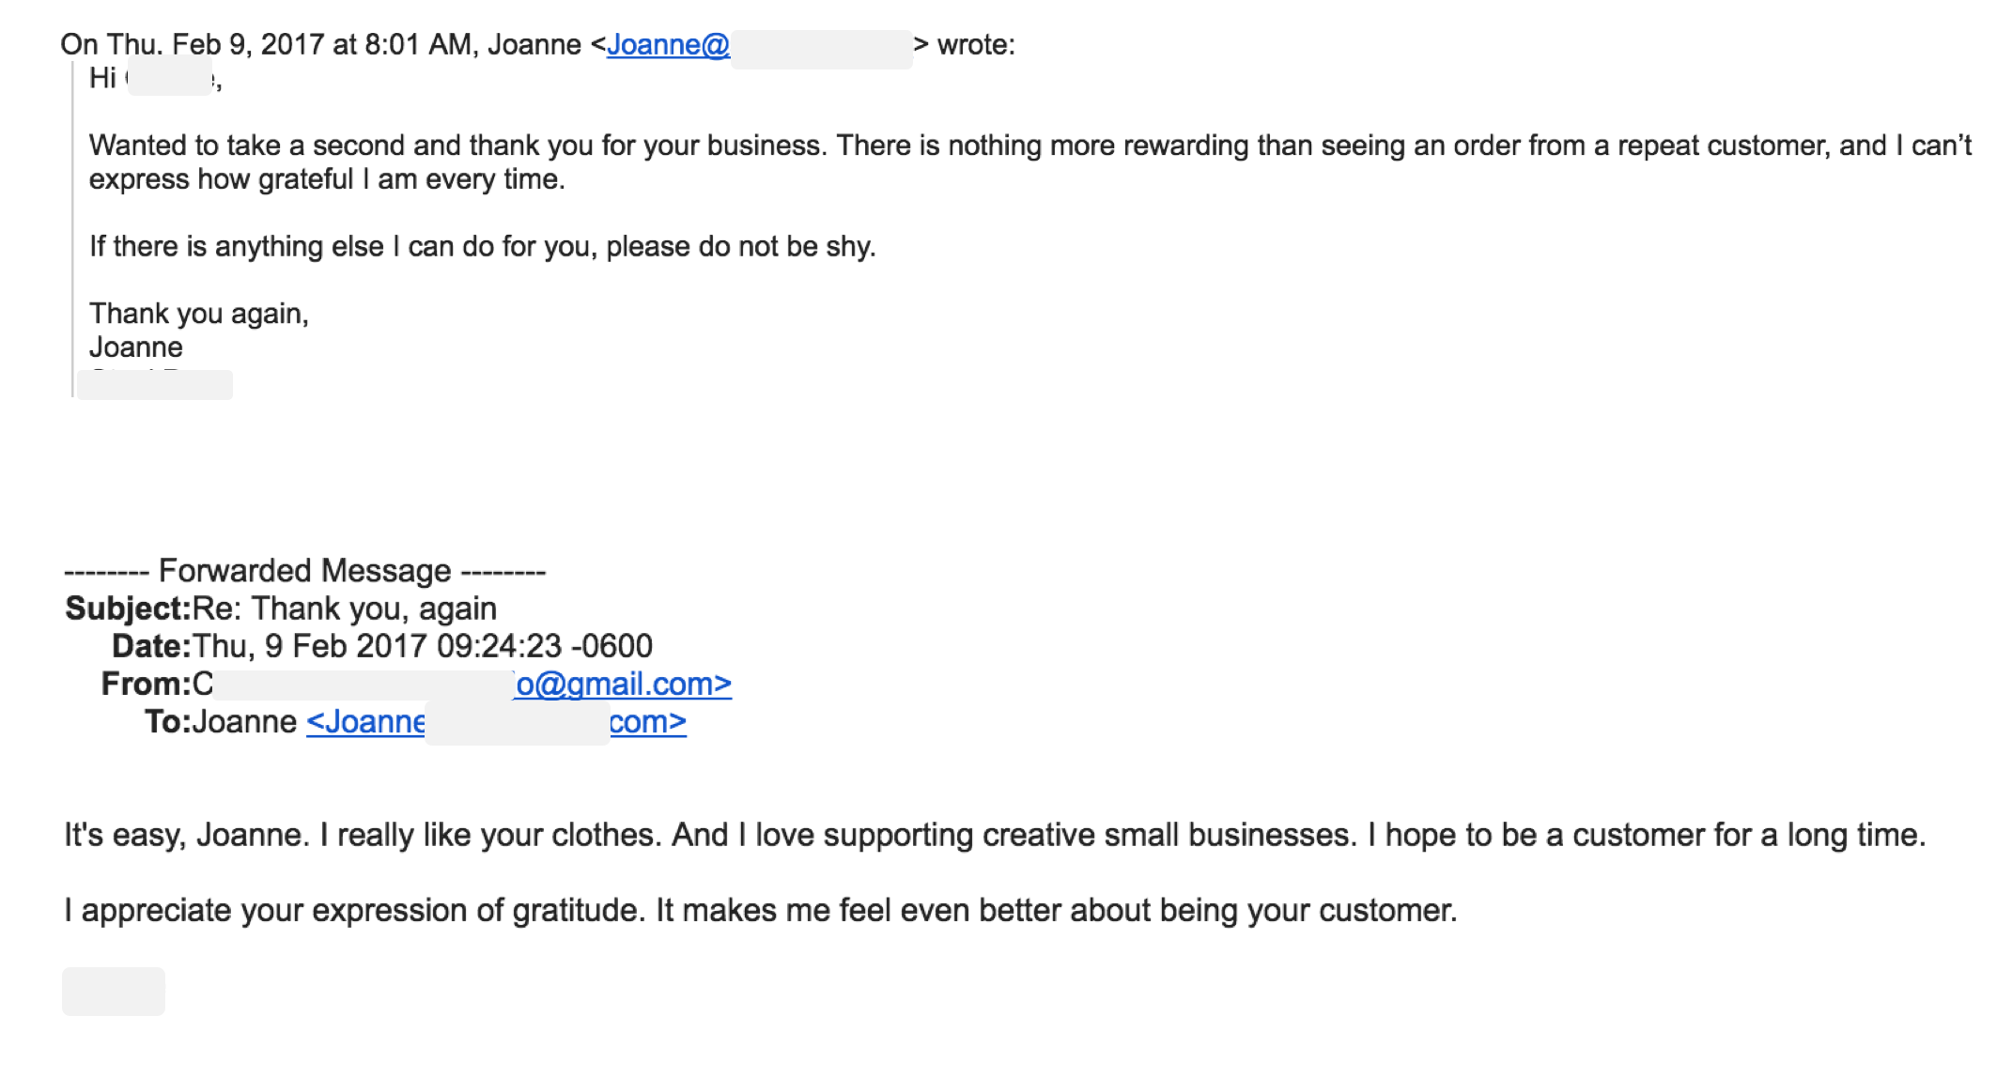
THANK YOU Email Template #1:

Send this to your best TOP 10 previous customers. Just copy and paste it one by one and personalize the name of the customer.

Subject Line: Thank you, again

Hi CUSTOMER NAME,
Wanted to take a second and thank you for your business. There is nothing more rewarding than seeing an order from a repeat customer, and I can’t express how grateful I am every time.
If there’s anything else I can do for you, please do not be shy.
Thank you again,
YOUR NAME
COMPANY NAME

THANK YOU Email Template #2:

Subject Line: WOW!!!! + a question in the P.S.

I woke up this morning thinking about YOU and wanted to send my sincere THANKS. Because of you and all those who support my business, I get to make people happy with my _______________________ (hand-made clothes, quirky t-shirts, cozy baby gear – what you do…) every single day. I mean WOW, you’re awesome.

So THANKS for being part of the COMPANY NAME community!

Sincerely,

YOUR NAME
*Just a girl who decided to go for it!

P.S. Could I get your opinion??

One idea for my new collection is ______________ and the other is _____________________. Whaddayathink? I’d love your honest feedback! Just REPLY to this email and let me know. ☺

THANK YOU Email Template #3::

Subject Line: THANK YOU!

Hi CUSTOMER NAME,
This is just a quick note to thank you SO MUCH for your support.

“When you buy from a small business an actual person does a little happy dance.”
I’m doing my own personal happy dance today and feeling so grateful!! I couldn’t do it without you so THANKS AGAIN!!

Sincerely,

YOUR NAME
The happiest entrepreneur on the planet

Image ideas (NOT necessary, but if you’re so inclined…)

Found this here: https://i.pinimg.com/originals/ad/76/2a/ad762a6199b95ac8d19769cc9684436f.jpg

This is for inspiration only!! You may NOT cut and paste this graphic as your own but you can share it on social media if you give credit.

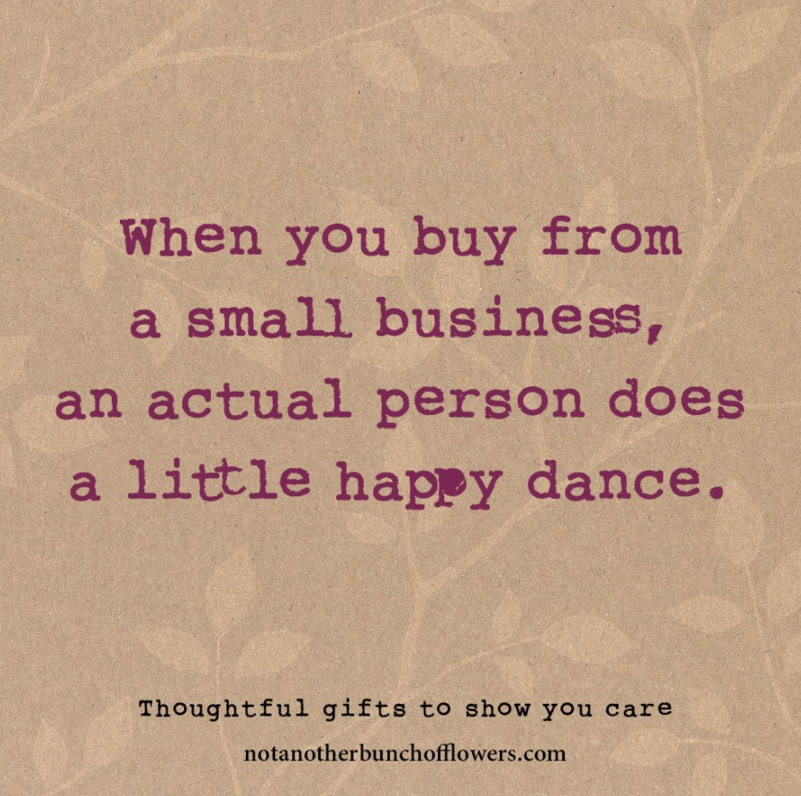

Another idea: http://picmia.com/745049

This is for inspiration only!! You may NOT cut and paste this graphic as your own but you can shre it on social media from the link above.



